Red Light, Green Light

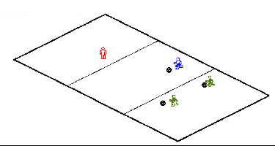

The Game
Each player has a ball except the player designated as the light. Lines from start to finish should be approximately 20-30 yards. Players start a line opposite the light. The player who is the light faces away from the group and calls out "green light". Players begin to dribble towards the light. When the light turns around and calls out "red light", players must freeze their bodies and the ball. If the light catches players still moving, or dribbling, he send them back tot he starting line. The first player to cross the line where the light is standing is the winner and becomes the new light.
Coaching Points
• Encourage players to dribble under close control.
• This drill promotes quick reactions and dynamic balance..

