Running Bases

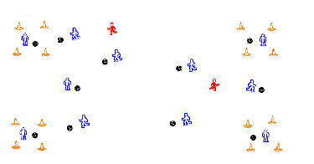

The Game
• Players try to dribble their ball without being tagged. If they get tagged, they exchange places with the "tagger"
• Have taggers carry a pinnie to distinguish themselves. Hand pinnies over to the player that is tagged and use their ball to dribble.
• Players are save in any one of the 4 bases. Only one player allowed in a base at one time. If a new players enters a base, the old player must leave.
Variations
For younger players:
- Only one tagger
- Fewer bases
- Only one player in a base at a time
For older players:
- More bases and taggers.
- 2 players allowed in each base.
- Play with fewer balls: can only be tagged if you have the ball. or, if you don't have a ball (balls must be passed).

